Lab Report 4

Team Members :
Name: Chanda Akshay Kumar
Roll No.: 2024102014
Name: Samadhi Venkata Santhosh Kumar yadav
Roll No.: 2024102054
Team I’D : 42

Name of the Experiment:
Zener Diode Shunt Voltage Regulator

Aim:
To construct a simple Zener Regulator circuit.
Materials Used:
- 5.6V Zener Diode
- Power Supply
- Connecting Wires
- Breadboard
4. Resistors(100Ω, 1KΩ, 3KΩ, 330Ω, 390Ω, 10KΩ)

- Digital Multimeter

Procedure:

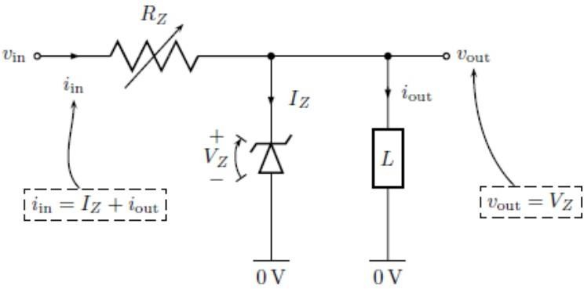

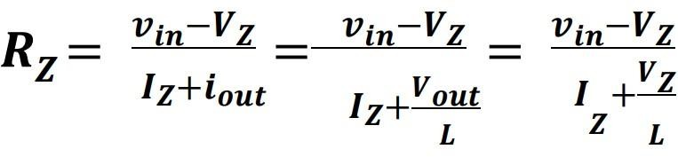

- Connect the circuit as shown in the diagram provided.

- Calculate the value of Rz using the formulae given.

- Measure the values of in and Vout using a multimeter. Keep the Load constant at 10KΩ and change the value of Rz. The input voltage should be kept at 15V.
- Record the results.

- Keep the value of Rz at 100Ω and change the Load Resistance. Take Vin = 15V. Calculate the values of in and Vout using a multimeter.
- Note down the results obtained.

Results:

Observations:

R(L) | V(OUT) | I(in)
10K(OHM) | 5.44V | 46.7
3.3K(OHM) | 5.42V | 46.8
1.2(OHM) | 5.42V | 46.9
470(OHM) | 5.39V | 47
100(OHM) | 4.94V | 49.3

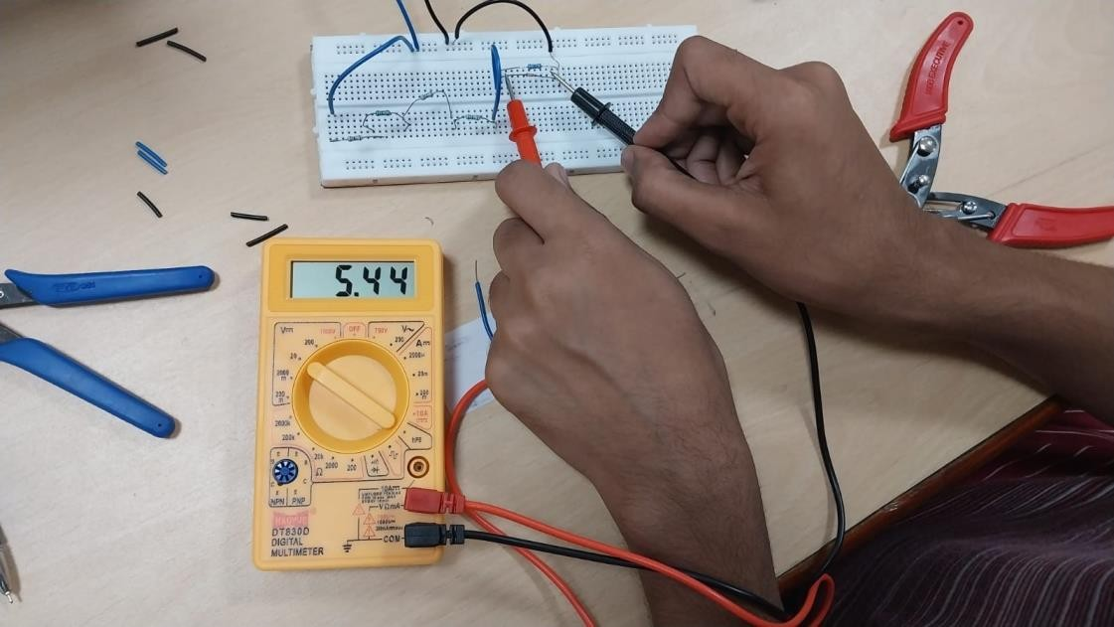

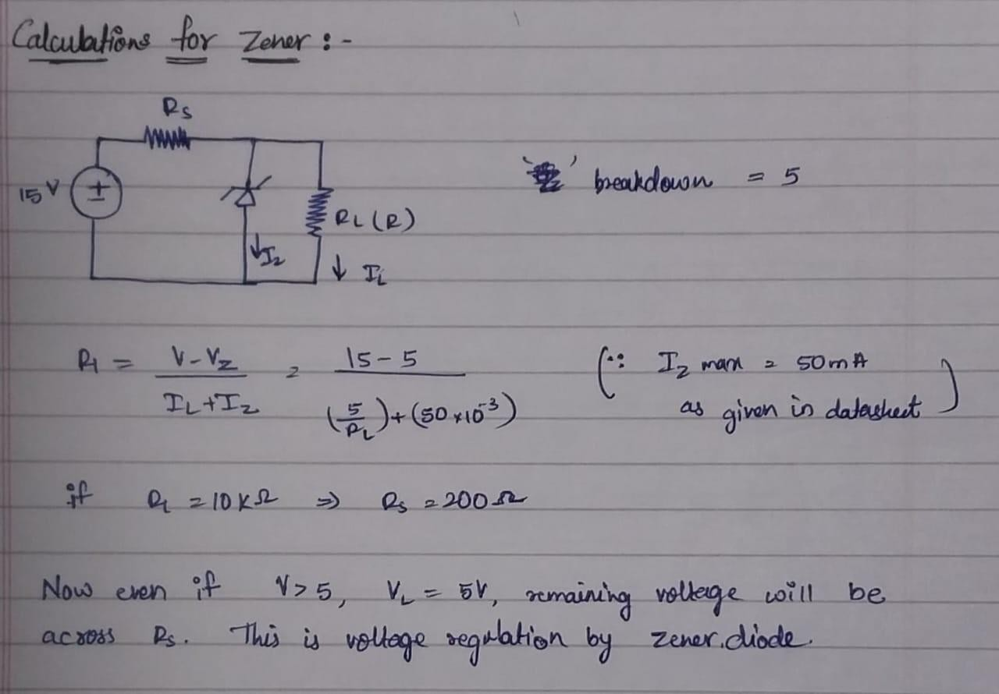

  - As we vary the resistance Rz, we can notice changes in the current and V out values. It is worth noting that Rz and Vout are inversely proportional.
  - Moreover, we can observe a slight decrease in the Vout values when the load resistance is reduced. However, the current flowing into the circuit remains the same, as the Rz value remains constant.

Conclusion:
We can conclude from the results that the Zener Diode breakdown voltage ranges from 5.6V to 6V and also that a zener diode can be used for voltage regulation.

Name of the Experiment:
LM317 Adjustable Positive Series Voltage Regulator

Aim:
To construct a simple circuit to use LM317 IC to regulate voltage.

Components Required:

- Breadboard
- LM317 IC

- Power Supply
- DMM

5. Resistors(10KΩ, 9KΩ, 4KΩ, 73KΩ, 2.2KΩ, 470Ω, 3.3KΩ)

Procedure:
1. Replace the 240Ω resistor and R1 with a 470Ω standard resistor.

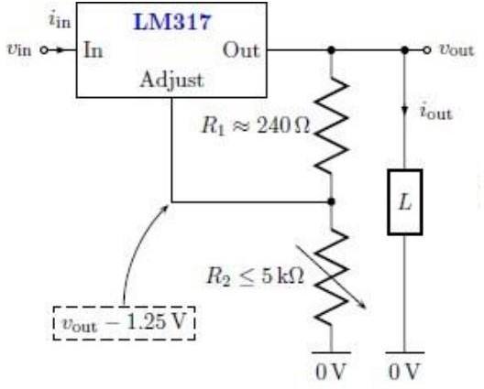
1. Use the formula provided below, keeping in mind that Adjust and Vout should have a potential difference of 1.25V and Vout(Desired) should be 10V.
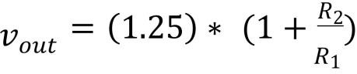

- Set the Load to 10KΩ, R1 to 470Ω, and R2 to 3.3KΩ. Then, use a DMM to calculate Vin and Vout, and take note of your observations.
- Fix Vin to 15V, and R1 and R2 to 470Ω and 3.3KΩ respectively. Calculate Vout by changing the Load Resistance, and write down the results.

Results:

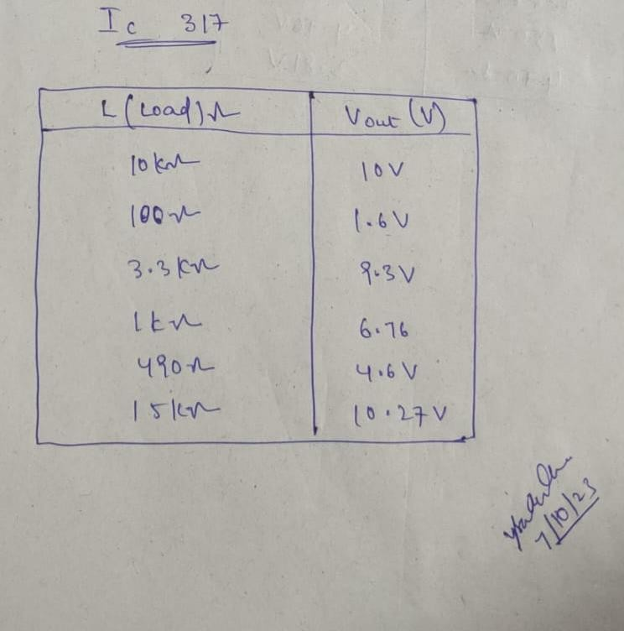

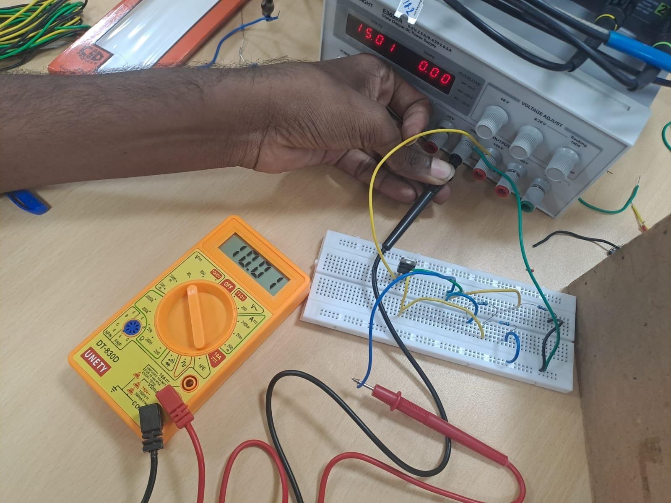
Observations:

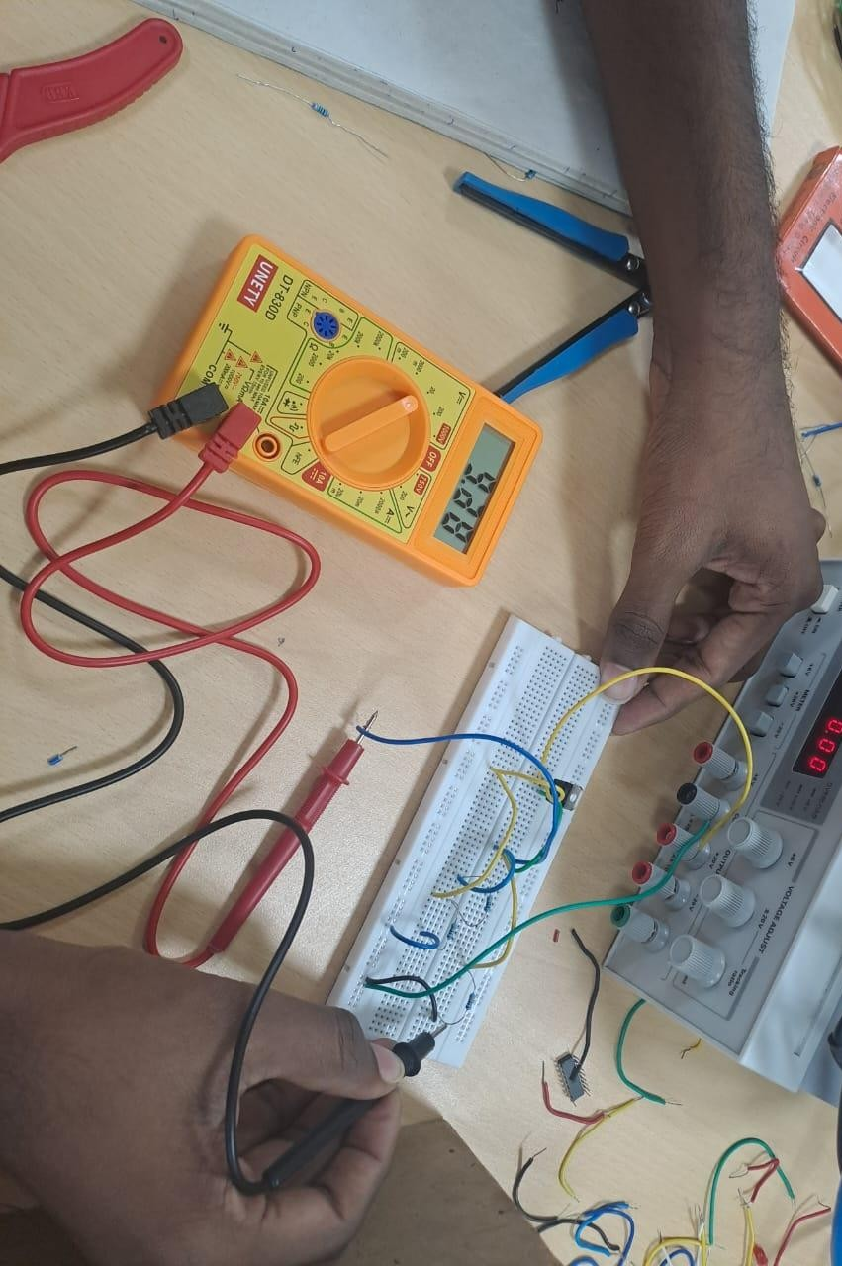

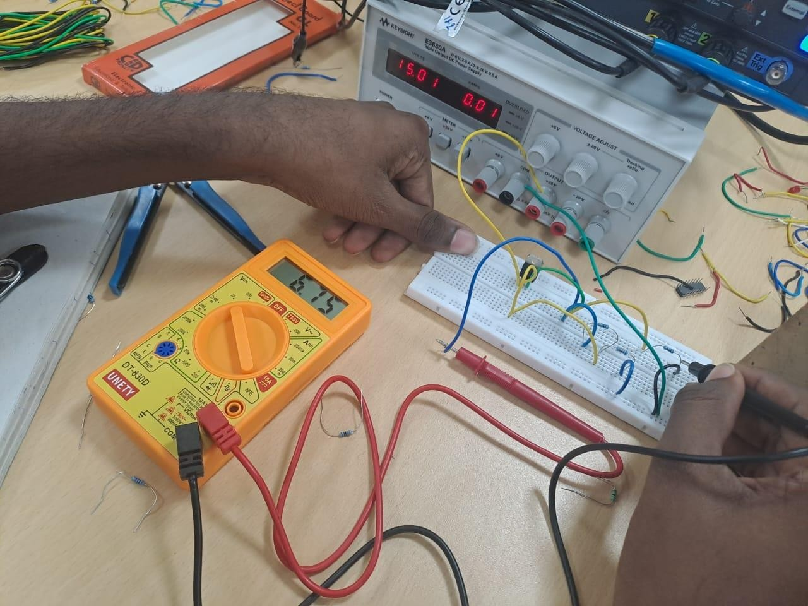

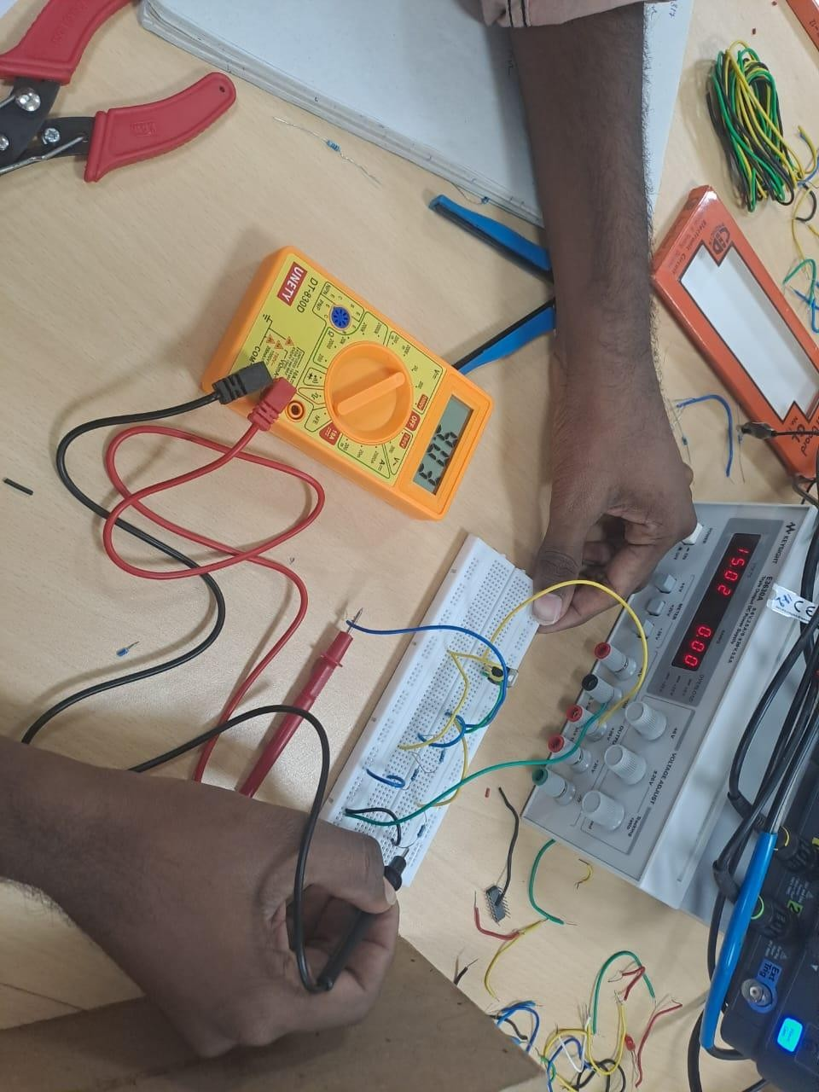

Conclusion:
We can conclude that the LM317 IC is a Voltage regulator.

Name of the Experiment:
LM7805 Voltage Regulator

Aim:
To construct a circuit to verify LM7805 IC as Line regulator and Load Regulator

Components Required:
- Breadboard
- Capacitors(0.22µF, 0.1µF)
- LM7805 IC
- Resistors(10KΩ, 9KΩ, 33KΩ, 400Ω, 4KΩ, 1.2KΩ)

- Power Supply
- DMM

LINE REGULATION:

Procedure:
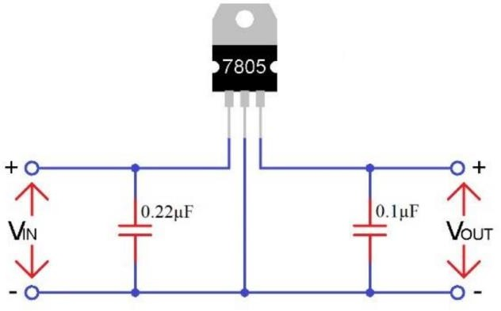
1. Connect the circuit according to the provided diagram.

- Change the input voltage using this circuit and observe the changes in Vout.

- Record your observations.

- Now, construct the circuit provided below to check load regulation.
- Keep Vin constant at 15V and vary the load resistance to measure Vout.

- Note down the results.

Results:
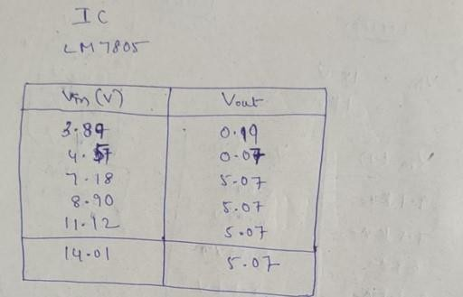

Observations:

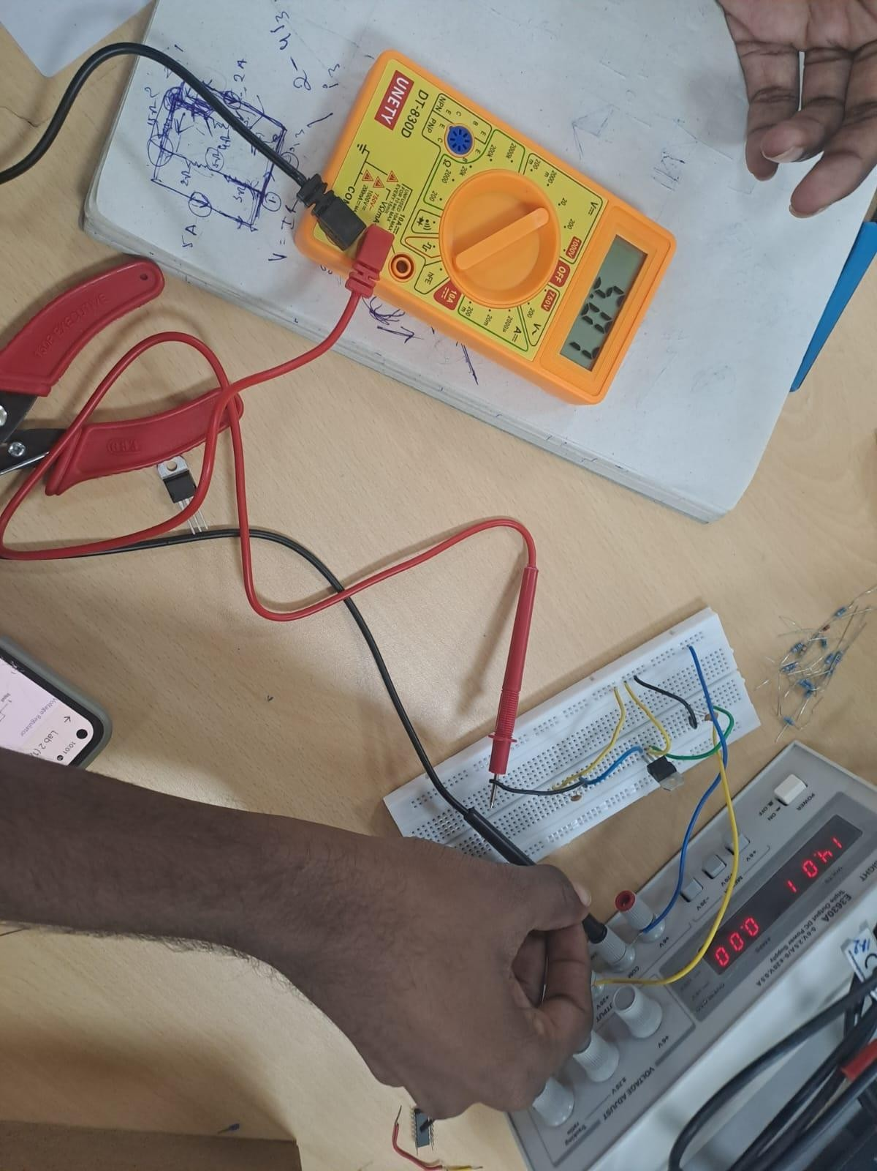

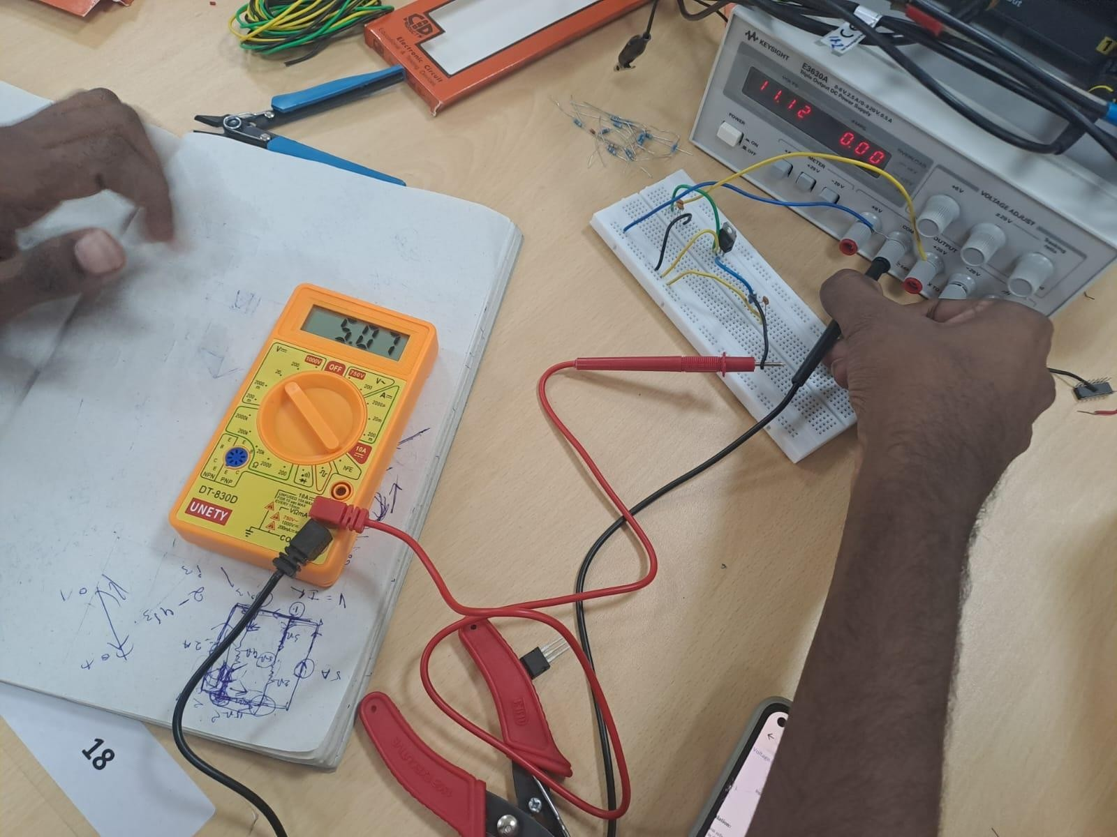

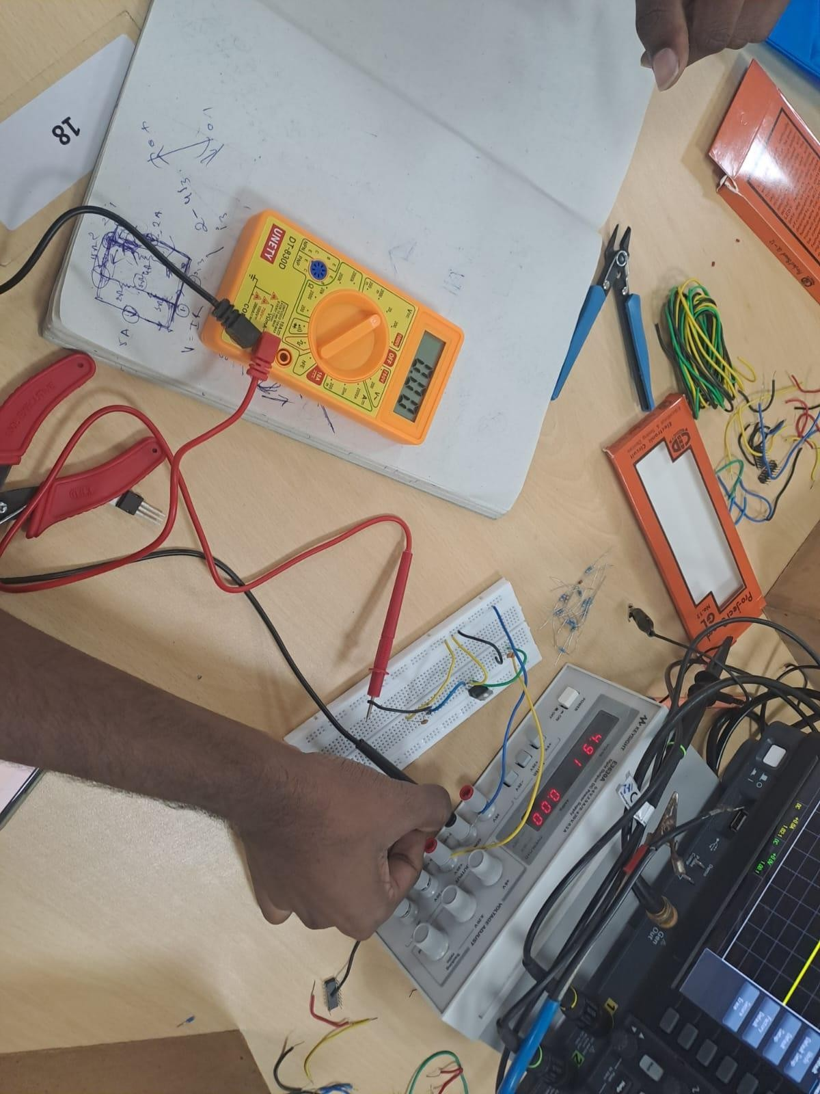

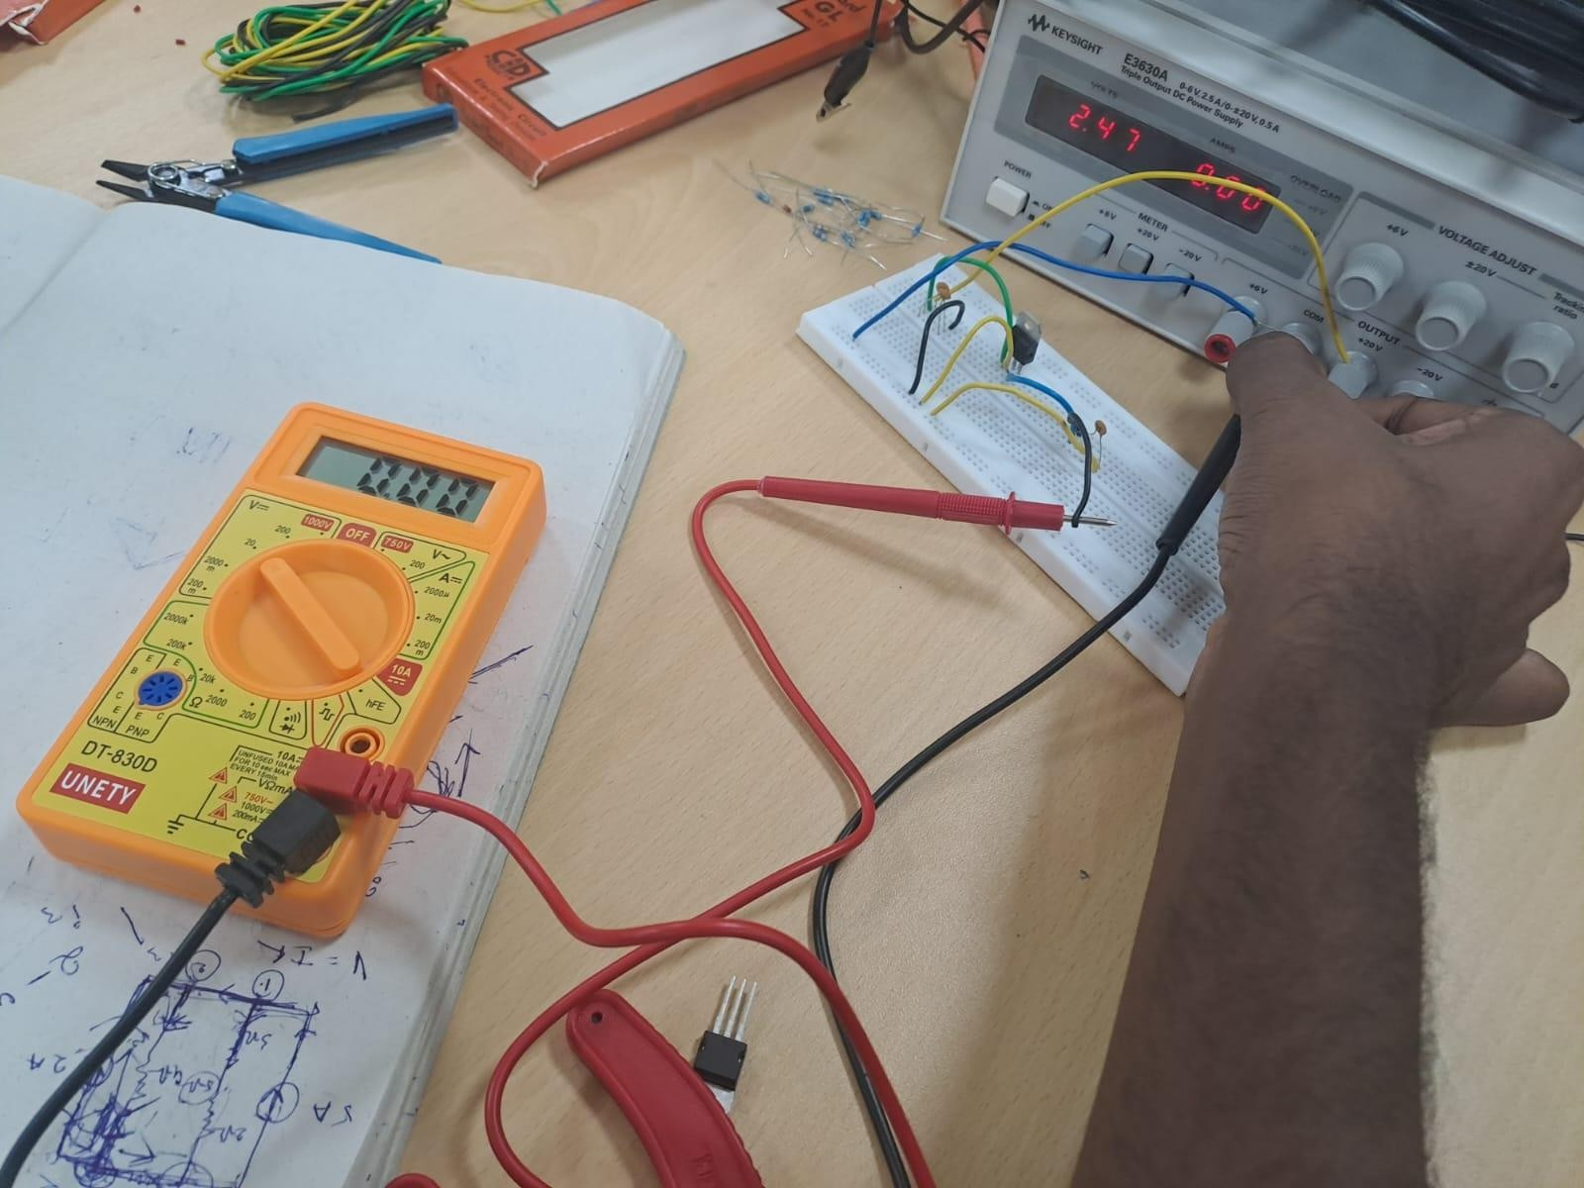
LOAD REGULATION:
Load regulation refers to the ability of a circuit to maintain constant (regulated) output voltage with change in the load resistance.
PROCEDURE:

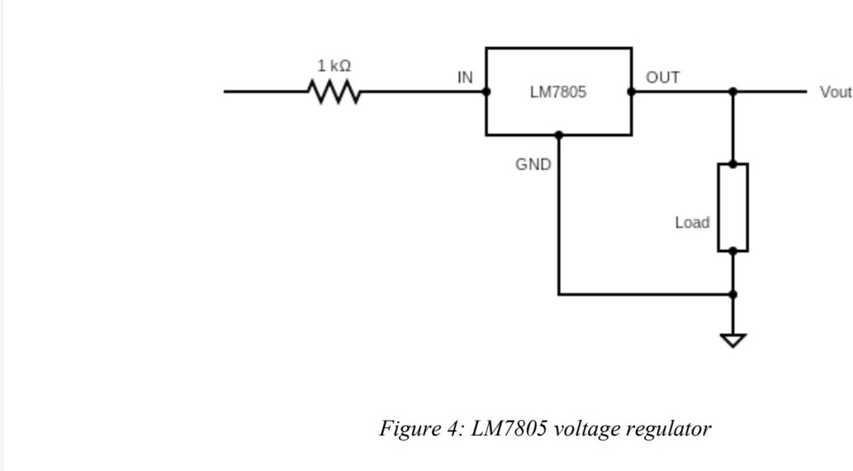

  - Apply a DC input of 15 volts and vary the load resistance in steps (at least 5) and measure the output voltage using your DMM.
  - Note the results and present them as a table. RESULTS:

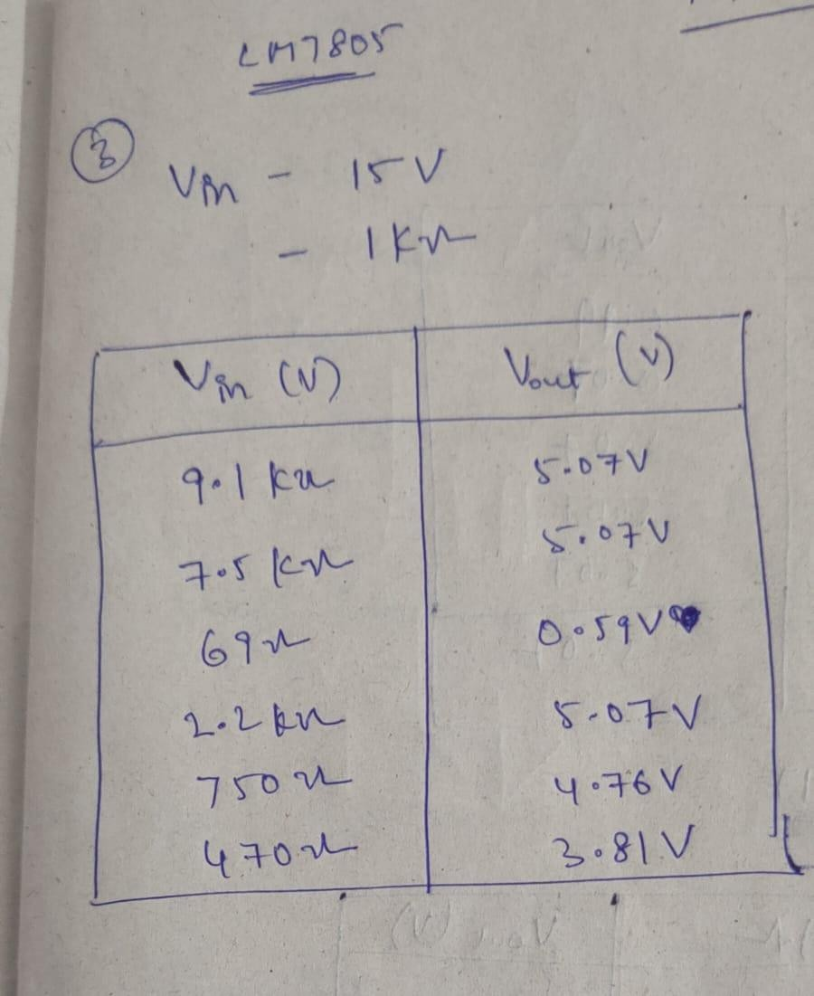

OBSERVATIONS:

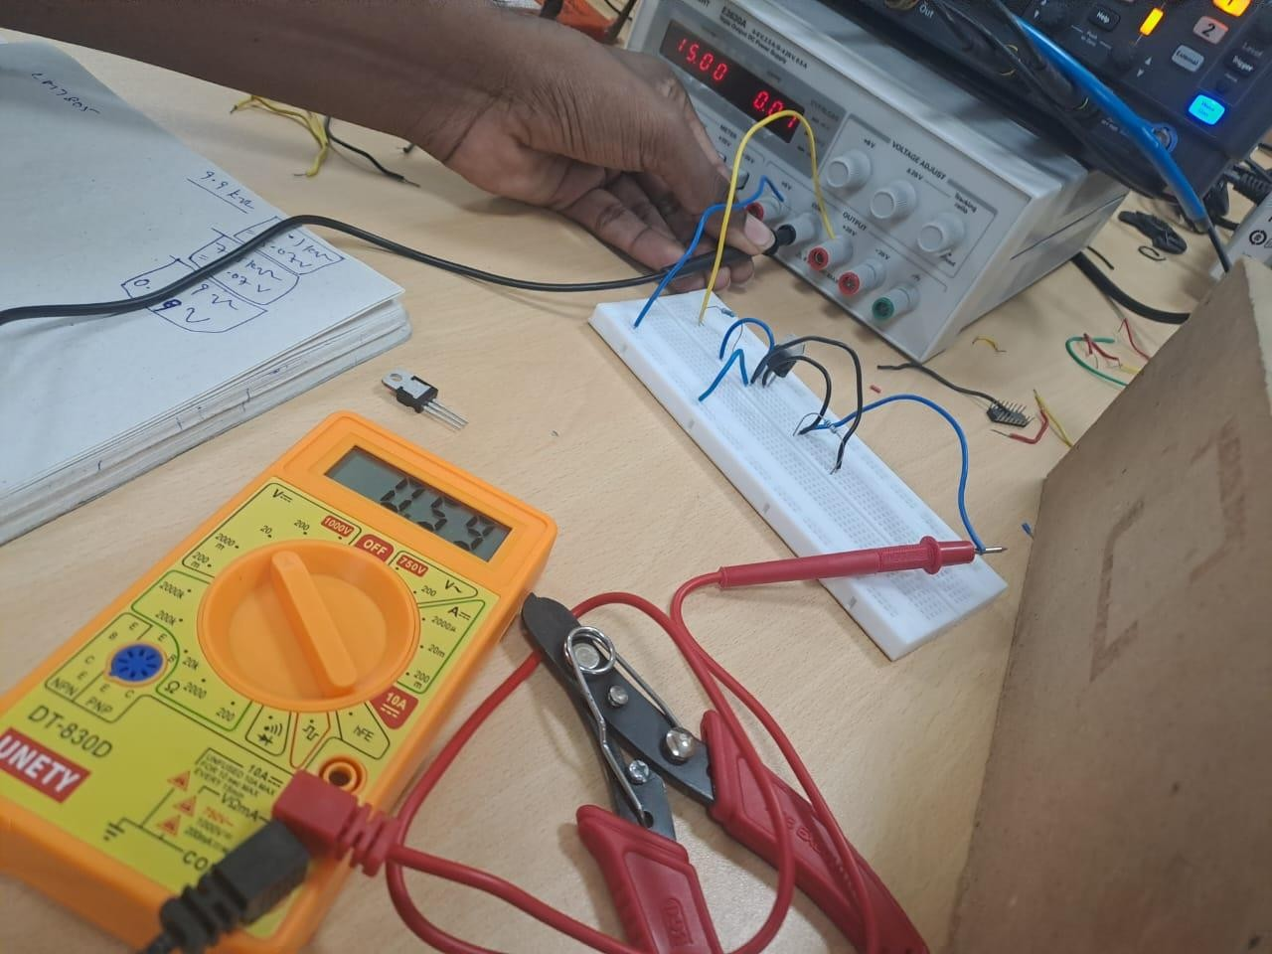

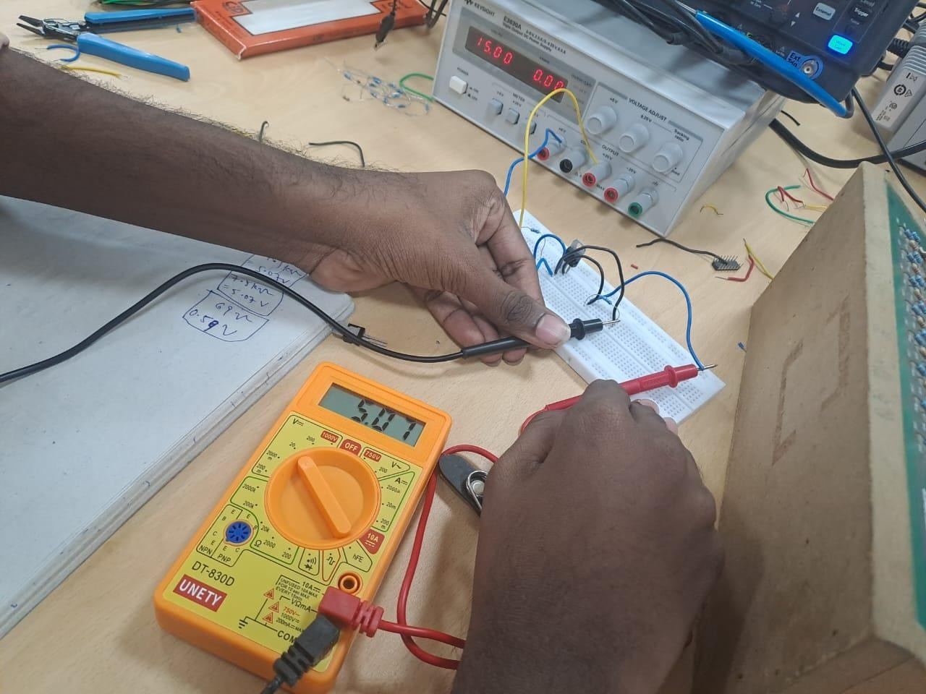

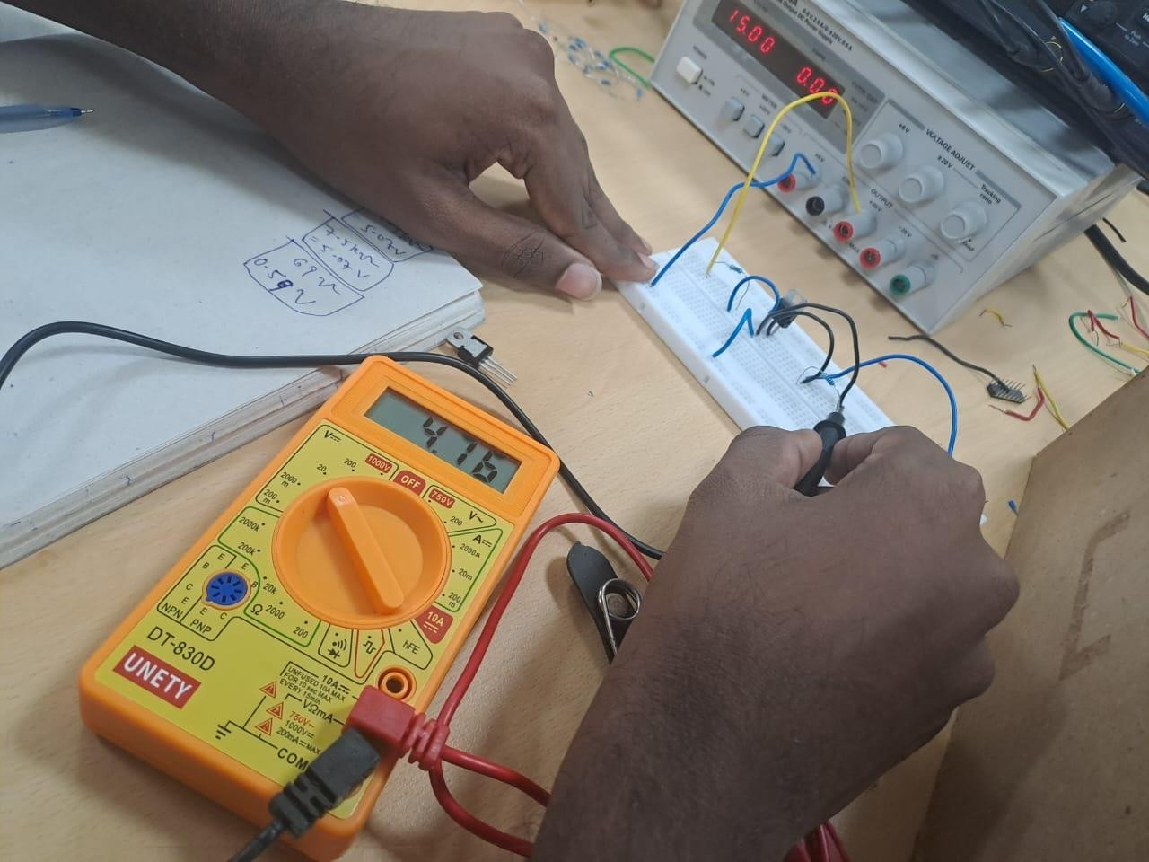

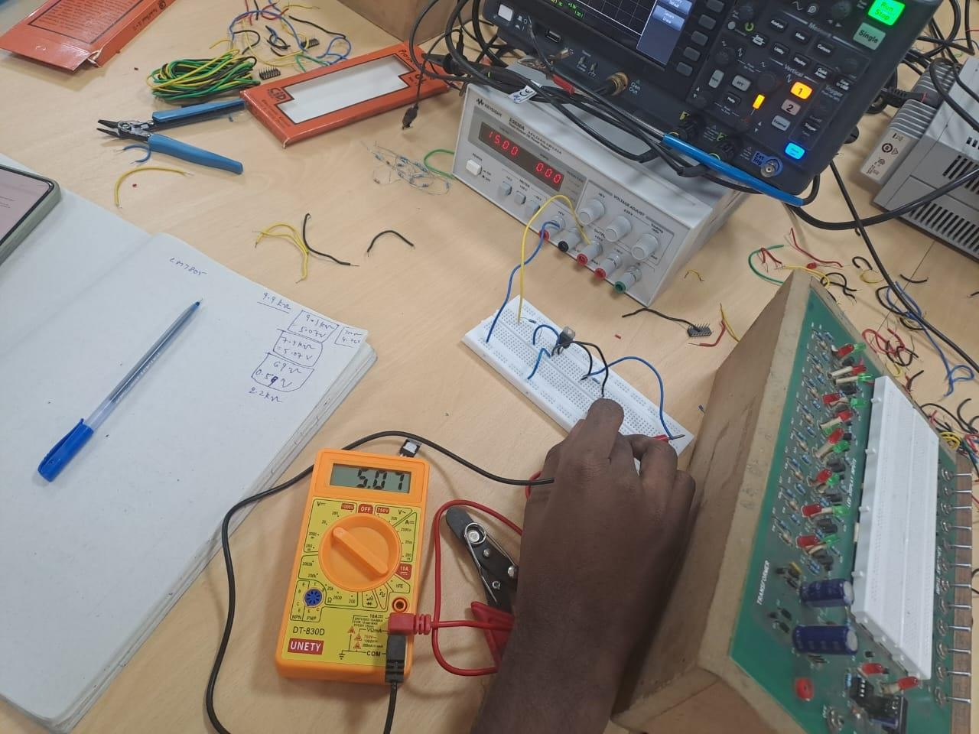

Conclusion:
We can conclude that the LM7805 IC can be used as a regulator.

